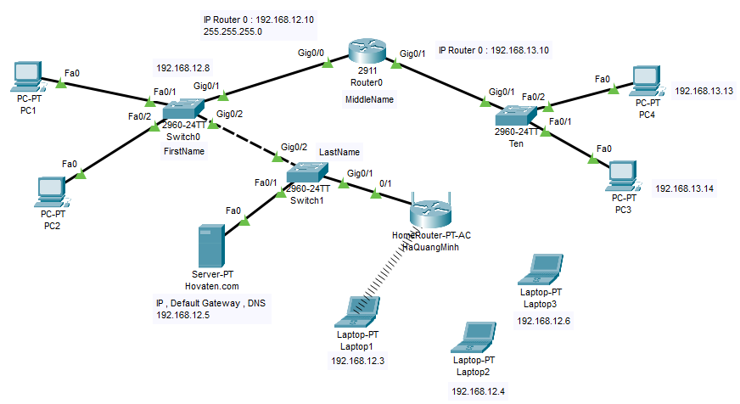

**How to way :**

1. Basic configuration on **switch FirstName**

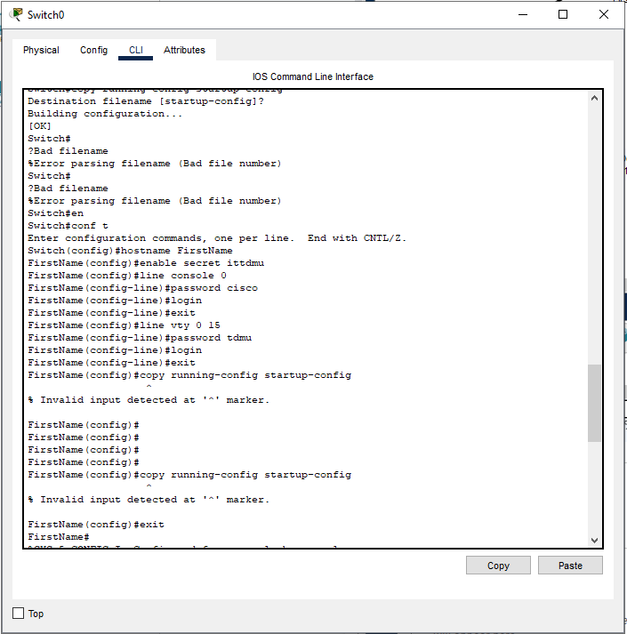

* On **switch LastName**

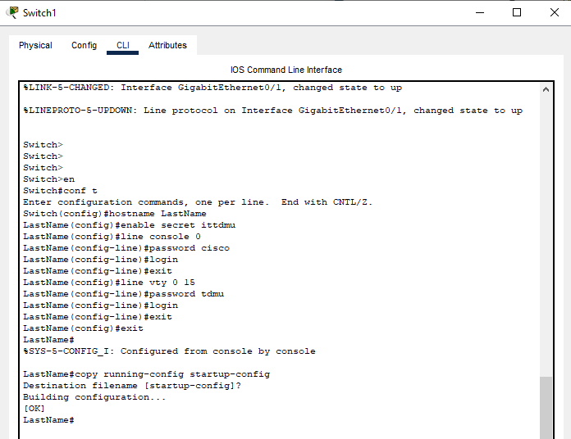

* **Router MiddleName :**

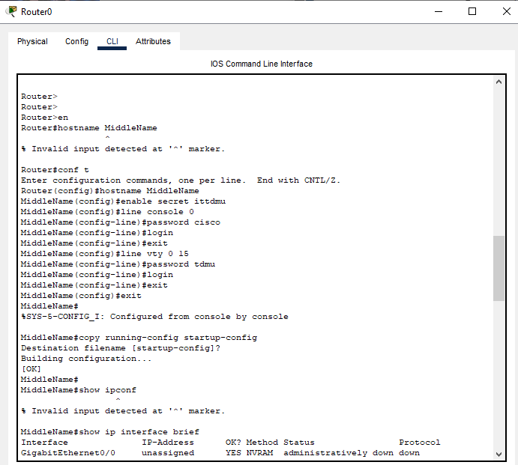

**Check to make sure the PCs ping through and ping through the Server**

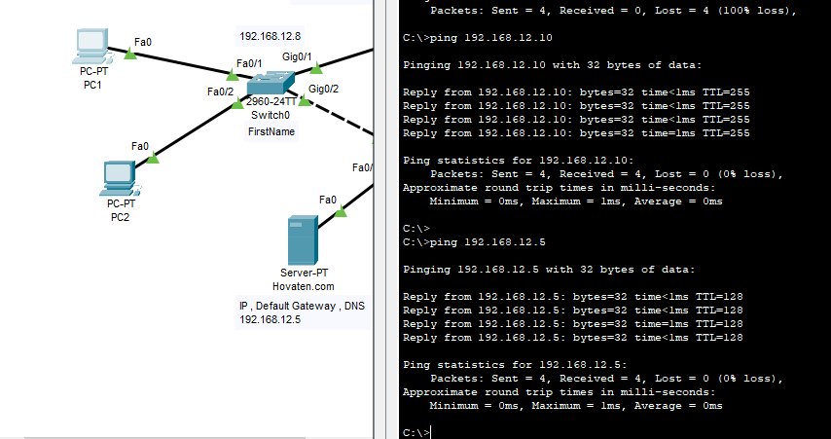

**Add wifi router and configure :**

**My answer below :**

